10.5 Problem Set

Be Prepared Textbook 32) 11 & 123) Question 2

Aviel Resnick

1. Page 32) #11
   1. 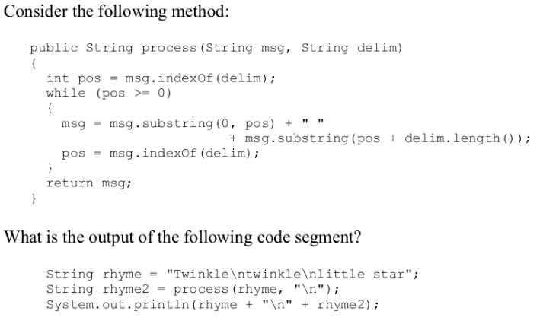
   2. I chose “E”, by following the code myself. The first portion, rhyme, contains newlines, so I wrote out what it would look like (with the newlines). Then I added a new line, and rhyme2. The process method, would take rhyme, and split it at the newlines, adding spaces instead. The result is a single line containing rhyme. The only option which matched that was E.
2. Page 123) Question 2
   1. 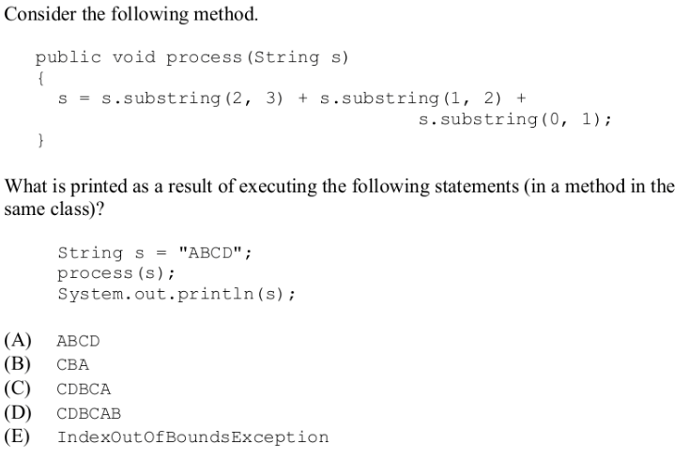
   2. For this one I choose B, as the end character is exclusive, so the result ends up being the 2 index (third char), 1 index (second char), and 0 index (first char). - CBA